DESIGN AND IMPLEMENTATION OF AN INTERGRATED ID CARD ACCESS CONTROL AND ATTENDANCE SYSTEM

BY

KHADIJA TUKUR JAMIL

BU/22A/IT/6097

DEPARTMENT OF SOFTWARE ENGINEERING,

FACULTY OF COMPUTING AND APPLIED SCIENCES

BAZE UNIVERSITY

ABUJA

AUGUST, 2024

DESIGN AND IMPLEMENTATION OF AN INTERGRATED ID CARD ACCESS CONTROL AND ATTENDANCE SYSTEM

Thesis submitted in partial fulfillment of the requirement

For the degree of

B.Sc.

In

Software Engineering

BY

Khadija Tukur Jamil

To

The Department of Software Engineering

Baze University, Abuja

AUGUST, 2024

**DECLARATION**

I, Khadija Tukur Jamil with ID Number: BU/22A/IT/6097 Hereby testify that, the project titled “Design and Implementation of an Integrated ID Card Access Control and Attendance System” is the outcome of my sole effort, under the supervision and guidance of Mr. Usman Abubakar. This project has not been presented or submitted elsewhere and all other materials used have been acknowledged and duly referenced in the reference page.

Date: AUGUST 2024 Name of student: Khadija Tukur Jamil

**APPROVED BY** ……………………………

**Head**

Department of Computer Science

**CERTIFICATION**

This is to certify that this project entitled “**Design and Implementation of an Integrated ID Card Access Control and Attendance System”**, which is submitted by **Khadija Jamil Tukur** in partial fulfilment of the requirement for the award of degree for B.Sc. in Software Engineering to the Department of Software Engineering, Baze University Abuja, Nigeria is a record of the candidate’s own work carried out by the candidate under my/our supervision. The matter embodied in this project is original and has not been submitted for the award of any other degree.

Date: Supervisor: Dr Usman Bello Abubakar

**APPROVAL**

This is to certify that the research work, **Design and Implementation of an Integrated ID Card Access Control and Attendance System** by Khadija Jamil Tukur with BU/22A/IT/6097 has been approved by the Department of Software Engineering, Faculty of Computing and Applied Science, Baze University, Abuja, Nigeria.

By

Dr Usman Bello Abubakar Date/Sign

Supervisor

Usman Idris Abubakar Date/Sign

Head, Department of Compuer Sciences

Prof. Aliyu  Date/Sign

Dean, Faculty of Computing and Applied Science

Prof Nyap Choji Davou

External Examiner Date/Sign

**DEDICATION**

This project report is dedicated to Almighty Allah (SWA), the creator, source of knowledge and wisdom. As well, my family, my lecturers, friends, colleagues and every other person that made a positive impact on my academic journey. With your support, love, advice and guidance everything came easier. I will forever be grateful to Allah (SAW) and everyone who supported me.

**ACKNOWLEDGEMENT**

I would like to express my deepest gratitude to all those who contributed to the successful completion of this project.

First and foremost, I would like to express my profound gratitude to God Almighty for providing me the opportunity to carry out my BSc.

I would also like to thank, Mr. Usman Abubakar, my supervisor, for his invaluable guidance, continuous support, and encouragement throughout this project. His insightful feedback pushed me to sharpen my thinking and brought my work to a higher level.

My sincere thanks also go to my classmates and colleagues, who assisted me in various ways and were always willing to help and give their best suggestions. Their support and collaboration were crucial for the progress and completion of this project.

A special thanks to my parents, Mr. and Mrs. Jamil Tukur, my siblings, Nafisa, Muhammad, Fatima, Ruqayya and Amira, for their unwavering support and encouragement throughout my studies. Their belief in me kept me going, even during challenging times.

Thank you all.

**ABSTRACT**

This project focuses on the design and implementation of an Integrated ID Card Access Control and Attendance System for Baze University. With growing security concerns and the need for efficient attendance tracking in academic institutions, this system provides a robust solution by combining RFID technology, smart cards, and cloud-based infrastructure. The system ensures that only authorized individuals can access restricted areas while automatically recording attendance in real time.

The project addresses key challenges, such as reducing unauthorized access, improving the accuracy of attendance records, and enhancing campus security. By integrating the system with existing campus management tools, such as payroll and human resource systems, the solution offers scalability and seamless operations.

The study leverages best practices in access control and attendance management while addressing gaps in existing technologies, such as data privacy and cost efficiency. The results demonstrate the effectiveness of this system in improving security, streamlining administrative tasks, and promoting a safer learning environment. This project provides a practical framework for the implementation of access control systems in similar institutional contexts.

**TABLE OF CONTENTS**

**DECLARATION .**……………………………………………………………………………………… 3

**CERTIFICATION .**…………………………………………………………………………………..... 4

**APPROVAL** ……………………………………………………………………………………………. 5

**DEDICATION** …………………………………………………………………………………………. 6

**ACKNOWLEDGEMENT** ……………………………………………………………………………. 7

**ABSTRACT** ………………………………………………………………………………………….. 8

**TABLE OF CONTENTS** ……………………………………………………………………………… 9

**LIST OF TABLES** …………………………………………………………………………………….. 11

**LIST OF FIGURES** …………………………………………………………………………………... 11

**CHAPTER ONE** 14

**INTRODUCTION** 14

**1.1** **Overview** 14

**1.2** **Motivation and Background** 14

**1.3** **Problem Statement** 15

**1.4** **Aim and Objective** 15

**1.5** **Significance of the Project** 16

**1.6** **Project Risks Assessment** 17

**1.7** **Project Scope and Limitations** 17

**CHAPTER TWO** 18

**LITERATURE REVIEW** 18

**2.1 INTRODUCTION (Purpose of Literature review)** 18

**2.2 HISTORICAL OVERVIEW AND EVOLUTION OF ACCESS CONTROL SYSTEM** 18

**2.2.1 Biometric-based Attendance and Access Control Systems** 18

**2.2.2 RFID-based Systems RFID (Radio Frequency Identification)** 19

**2.2.3 Smart Card-based Attendance and Access Control Systems** 19

**2.2.4 Cloud-based Attendance and Access Control Systems** 19

**2.2.5 INTEGRATION WITH ERP AND HR SYSTEMS** 20

**2.3 CHALLENGES AND GAPS IN THE LITERATURE** 20

**SYSTEM ANALYSIS AND DESIGN** 22

**3.1 INTRODUCTION** 22

**3.1.2 DESCRIPTION OF THE NEW SYSTEM** 22

**3.2 REQUIREMENT SPECIFICATION** 22

**3.2.1 FUNCTIONAL REQUIREMENTS** 22

**3.2.2 NON-FUNCTIONAL REQUIREMENTS** 23

**3.3.1 DATA MODEL (ENTITY RELATIONSHIP DIAGRAM)** 26

**3.3.2 USE CASE DIAGRAM** 26

**3.3.3 ACTIVITY DIAGRAM** 29

**3.3.3 DATA FLOW DIAGRAM** 30

**CHAPTER FOUR** 31

**SYSTEM IMPLEMENTATION** 31

**4.1 INTRODUCTION** 31

**4.2 TOOLS AND LANGUAGES USED** 31

**4.2.1 Visual Studio code (VS code)** 31

**4.2.2 Python** 31

**4.2.3 Django** 31

**4.2.4 Mailtrap.io** 32

**4.3 USER INTERFACE** 32

**4.3.1 STUDENT USER INTERFACE** 32

**4.3.2 ADMIN USER INTERFACE** 33

**4.3.3 DATA BASE IMPLEMENTATION** 37

**4.4 SYSTEM TESTING** 37

**CHAPTER FIVE** 41

**DISCUSSION, CONCLUSION AND RECOMMENDATION** 41

**5.1 OVERVIEW** 41

**5.2 OBJECTIVE ASSESSMENTS** 41

**5.3 LESSONS LEARNED** 41

**5.4 LIMITATIONS AND CHALLENGES** 42

**5.5 FUTURE ENHANCEMENTS** 42

**5.6 RECOMMENDATIONS** 42

**5.7 SUMMARY** 42

**REFRENCES** 44

**LIST OF TABLES**

Table 2.1 Comparative Analysis

Table 3.1 functional Requirements

Table 3.2 Non-functional Requirements

Table 3.3 Access control and Validation use case

Table 3.4 Attendance Login and Validation use case

Table 4.1 Summary of functionality test

Table 4.2 Summary of Non-functionality test

**LIST OF FIGURES**

Figure 3.1 Entity Relationship Diagram

Figure 3.2 Use Case Diagram 1

Figure 3.3 Use Case Diagram 2

Figure 3.4 Activity Diagram

Figure 3.5 Data Flow Diagram

Figure 4.1 Student login page

Figure 4.2 Student Dashboard

Figure 4.3 Attendance QR code Scanner

Figure 4.4 Access Areas

Figure 4.5 Admin Dashboard

Figure 4.6 Student list

Figure 4.7 Add student 1

Figure 4.8 Add student 2

Figure 4.9 Course List

Figure 4.10 Add Course

Figure 4.11 Attendance List

Figure 4.12 Add Area

Figure 4.13 Area List

Figure 4.14 Map Student Area

Figure 4.15 Student Areas

Figure 4.16 Student List

# **CHAPTER ONE**

# **INTRODUCTION**

## **Overview**

This project, titled "Design and Implementation of an Integrated ID Card Access Control and Attendance System for Baze University," aims to enhance the security and efficiency of the university by developing a system that manages access to restricted areas and automates attendance tracking.

## **Motivation and Background**

Baze University, like many other academic institutions, faces the challenge of managing access to its facilities and maintaining accurate attendance records. In the current environment, where security concerns are heightened due to the insecurity in Nigeria, there is a pressing need for solutions that can provide both safety and operational efficiency.

Existing methods of access control, such as manual checks or less sophisticated systems, are often inadequate in addressing the complex needs of a growing university. Additionally, manual attendance tracking can be time-consuming, error-prone, and difficult to manage at scale. These challenges highlight the necessity for a more integrated approach that uses modern technology to ensure both security and efficiency.

The motivation for this project is driven by the critical need to enhance the security of Baze University, particularly in the context of the growing insecurity in Nigeria. Ensuring the safety of students, faculty, and staff, as well as protecting university property, has become a top priority. Traditional methods of access control and attendance tracking have proven to be inefficient and prone to errors, making it important to develop a more reliable and automated system.

By implementing an integrated ID card system, the university can not only secure its facilities against unauthorized access but also ensure accurate and efficient monitoring of attendance. This system will help mitigate risks associated with unauthorized access, theft, and other security threats, thereby creating a safer and more secure learning environment.

## **Problem Statement**

Baze University, like many other educational institutions, faces significant challenges in ensuring the security of its premises and the accurate tracking of attendance for students, faculty, and staff. The current methods of access control, which may involve manual checks or outdated systems, are inadequate in addressing the university’s growing needs. These methods are often prone to human error, time-consuming, and lack the necessary robustness to prevent unauthorized access effectively.

The issue of security is further compounded by the increasing insecurity in Nigeria, where educational institutions have become potential targets for theft, vandalism, and other security threats. This situation has heightened the need for a more reliable and efficient approach to securing university facilities.

Additionally, the existing process for tracking attendance at Baze University is inefficient, leading to inaccuracies in records that can affect administrative tasks, student evaluation, and overall accountability. The manual processes currently in use are not only labor-intensive but also susceptible to errors, in the sense that the records may be lost or damaged. which can undermine the credibility of attendance records.

The combination of these factors underscores the urgent need for an integrated solution that can simultaneously address the issues of access control and attendance management. The proposed Integrated ID Card Access Control and Attendance System aims to resolve these challenges by providing a secure and reliable method for managing access to university facilities and accurately tracking attendance.

## **Aim and Objective**

The aim of this project is to design and implement an Integrated ID Card Access Control and Attendance System for Baze University, which enhances the security of the university's premises and automates the process of attendance tracking. This system will ensure that only authorized individuals can access specific areas while providing accurate and efficient attendance records. To achieve this aim, the following specific objectives are outlined:

1. Implement RFID or smart card technology to control access to restricted areas within Baze University.
2. Integrate the system to automatically log entry and exit times for accurate attendance records.
3. Develop a user-friendly interface for managing access and attendance records.
4. Reduce unauthorized access and improve overall campus security.
5. Design the system to allow for future expansion and integration with other systems.

## **Significance of the Project**

The "Design and Implementation of an Integrated ID Card Access Control and Attendance System" for Baze University holds substantial significance in enhancing campus security, improving operational efficiency, and supporting the university's growth. In an era where insecurity is a growing concern in Nigeria, this project provides a crucial solution to safeguarding students, staff, and university property. By restricting access to authorized individuals only, the system helps mitigate potential security threats, creating a safer and more secure environment for learning and teaching.

Moreover, the automation of attendance tracking addresses inefficiencies inherent in manual record-keeping. This system ensures that attendance records are accurate and reliable, which is vital for various administrative tasks, such as student evaluations and resource planning. The system maximizes the use of university resources by eliminating manual involvement and allowing staff to focus on key responsibilities. By minimizing the need for manual involvement, the system improves the utilization of university resources, allowing staff to focus on more important tasks.

In addition to the above benefits, the project promotes data-driven decision-making at Baze University. With reliable, real-time access and attendance data, the administration can make educated judgments about security policy and academic planning. This skill not only helps the university's response to incidents, but also its overall management efficiency.

The system's design takes into account the university's long-term growth. Its scalability and flexibility to integrate with other campus management systems ensure that it will remain a useful tool as the school grows. Finally, the deployment of this modern, technology-driven approach strengthens Baze University's reputation as a forward-thinking university that values innovation and community safety. This project therefore serves as not simply a practical answer to current issues, but also a long-term strategic investment in the university's success.

## **Project Risks Assessment**

Potential risks Include insufficient user Training, hardware failures, power outages, data breaches, software bugs, budget delays, natural disasters and resistance to change and system compatibility. A comprehensive risk assessment will be carried out to evaluate the potential impact of risk, prioritizing them in order of significance.

To mitigate such risks, strategize will focus on user training, regular software and hardware maintenance, UPS systems, data protection policies, data encryption, contingency planning, disaster recovery plans, change management and system compatibility testing. With the strategies mentioned, it can be safe to point out that the risks will be mitigated to avoid potential system disruption and inconvenience.

## **Project Scope and Limitations**

The project scope includes designing and implementing an RFID or smart card-based access control system, developing a user-friendly interface for managing attendance data and access permissions, providing staff and student training, and integrating the system with the university's existing infrastructure.

Budget limits, potential security concerns, technological infrastructure constraints, system integration issues, and user resistance to change can all have an impact on project delivery.

# **CHAPTER TWO**

# **LITERATURE REVIEW**

## **2.1 INTRODUCTION (Purpose of Literature review)**

The objective of the literature review is to analyze and summarize current research and information relevant to the project, providing context and laying the foundation for the work. It is useful in identifying gaps in current knowledge in order to explain the project's need. Reviewing previous research makes it easier to guide system design and implementation using standard technologies and guidelines. The literature assessment also aids in the development of a theoretical framework, guaranteeing that the project is research-based and makes a significant contribution to tackling the difficulties of access control and attendance systems.

## **2.2 HISTORICAL OVERVIEW AND EVOLUTION OF ACCESS CONTROL SYSTEM**

The early access control systems were physical, making use of locks, keys, and mechanical barriers to secure buildings. These were gradually replaced by magnetic stripe cards and numeric keypad devices (Jayasuriya, 1995). Biometric systems and RFID technologies grew in demand as corporations wanted increased security. These advances addressed significant flaws, such as the ease of duplicating or stealing keys or codes, resulting in increased security.

In the early 2000s, biometric systems based on unique physiological traits (e.g., fingerprints and retina patterns) were introduced. These technologies, paired with networked infrastructure and cloud-based solutions, enabled real-time monitoring, remote access control, and interaction with other systems like payroll and human resource management (Sharma et al., 2012).

## **2.2.1 Biometric-based Attendance and Access Control Systems**

Biometric systems use human features, such as fingerprints, eyes and facial recognition for authentication. These systems are considered to be highly secure, making them a great option for access control and attendance systems. According to Jain et al. (2011), biometric systems are more secure as the likelihood of duplicating biometric identifiers are very low compared to key based or password systems. Kim et al (2014), stated that the use of fingerprint-based systems enhances the security of access control systems in academic institutions, thereby reducing unauthorized access and enhancing the efficiency of attendance monitoring.

## **2.2.2 RFID-based Systems RFID (Radio Frequency Identification)**

This technology has grown popular for attendance and access control for its non-contact and quick scanning capabilities. An RFID system consists of an RFID tag, a reader, and a database system that maintains attendance and access data (Kaur and Singh, 2013). Unlike barcode systems, RFID can identify items from a distance without having a line of sight.

Yadav et al. (2015) demonstrated the usefulness of RFID in a business setting by showing how RFID-enabled employee ID cards improved attendance tracking and access management. The system decreased human error, removed the need for manual attendance records, and enabled continuous surveillance of employee access to secure locations.

## **2.2.3 Smart Card-based Attendance and Access Control Systems**

Smart cards store encrypted information on an embedded microchip and are used for authentication in both physical and digital access control systems. Compared to magnetic stripe cards, smart cards provide enhanced security and flexibility for multiple applications, such as building access, network login, and payment systems (Wright, 2014).

Martínez et al. (2017) described the successful implementation of a smart card-based system in a corporate environment. Employees used a single smart card for access control, attendance logging, and purchases at company cafeterias, integrating various aspects of daily operations into a unified system. Although smart card systems are generally secure, Bell and Coates (2019) cautioned that card theft remains a concern. To address this, organizations often implement multi-factor authentication by combining the smart card with PINs or biometric verification.

## **2.2.4 Cloud-based Attendance and Access Control Systems**

Cloud computing transformed attendance and access control systems by providing monitoring, data synchronization, and scalable options that reduce hardware costs. Cloud-based technologies provide for centralized facility management, real-time updates, and effortless interaction with other corporate systems such as payroll and human resources (Johnson & Lee, 2019).

Yusuf and Abu-Salem (2020) examined the implementation of a cloud-based access control system in a global organization. Their findings revealed that cloud-based systems increased efficiency, lowered infrastructure costs, and enabled more advanced data analytics for attendance tracking. However, Patel et al. (2019) raised concerns about data security and potential breaches in cloud-based systems, highlighting the importance of strong encryption, secure data transmission protocols, and strict access controls.

## **2.2.5 INTEGRATION WITH ERP AND HR SYSTEMS**

Modern attendance and access control systems are increasingly being integrated into enterprise resource planning (ERP) and human resource (HR) management systems to improve worker management. This interface supports payroll automation, time management, and labor law compliance (Prasad et al., 2018).

## **2.3 CHALLENGES AND GAPS IN THE LITERATURE**

While great progress has been made in access control and attendance systems, some issues and gaps remain, creating opportunity for further research:

1. Security Concerns: Many research has focused on access control system weaknesses, but new dangers continue to develop, particularly in light of improved hacking tactics. For example, RFID and smart card systems are subject to cloning, skimming, and unauthorized access, creating substantial security issues.
2. Privacy issues: The use of biometric technologies and the collecting of personal information for access control raises privacy problems. Current research frequently ignores the ethical implications of storing and handling sensitive biometric and personal data, as well as the risk of misuse or illegal access to this information.
3. Scalability and Integration: Many access control and attendance systems are not scalable, particularly when used by large institutions or companies with expanding infrastructures. Integrating new systems with existing security standards, such as outdated hardware or software, presents technological obstacles.
4. Cost and Implementation: Implementing advanced access control and attendance systems can be costly, particularly in developing nations or institutions with limited resources. This difficulty could be addressed through research into cost-effective solutions, such as open-source technologies.
5. Reliability and System Downtown: Another research gap is the reliability of access control systems, especially in places prone to power outages or technical malfunctions.

**2.5 COMPARATIVE ANALYSIS**

*Table 2.1 Comparative Analysis*

|  |  |  |  |
| --- | --- | --- | --- |
| **AUTHORS** | **METHODOLOGY** | **STRENGHT** | **WEAKNESS** |
| Jayasuriya (1995) | Physical locks, keys, and mechanical barriers | Easy to implement and cost-effective for small-scale security | Susceptible to theft, duplication, and limited scalability |
| Jain et al. (2011) | Biometric systems (fingerprint, retina) | Highly secure; low likelihood of duplication | High implementation costs; raises privacy concerns |
| Kim et al. (2014) | Fingerprint-based systems in academia | Enhanced security and efficient attendance monitoring | May require regular maintenance to ensure accuracy |
| Kaur & Singh (2013) | RFID-based systems | Non-contact, fast scanning, no line-of-sight required | Vulnerable to skimming and cloning |
| Yadav et al. (2015) | RFID-enabled employee ID cards | Reduces human error and enables real-time monitoring | Requires significant infrastructure investment |
| Wright (2014) | Smart card-based systems | Secure and flexible for multiple applications | Risk of card theft unless multi-factor authentication is used |
| Bell & Coates (2019) | Smart card systems with encryption | Provides enhanced security through encryption | Risk of theft without additional security layers |
| Johnson & Lee (2019) | Cloud-based access control systems | Real-time monitoring and centralized management | Potential for data breaches without proper encryption |
| Yusuf & Abu-Salem (2020) | Cloud-based systems in global organizations | Scalable, cost-efficient, and integrated with analytics | Dependent on stable internet connection; risks of downtime or outages |

**2.5 CONCLUSION**

Attendance and access control systems have changed in response to advances in biometric, RFID, smart card, and cloud-based technology. These systems improve security, efficiency, and integration with organizational operations, particularly for workforce management and payroll automation. However, issues such as privacy, cybersecurity threats, and implementation costs must be addressed. Future research should focus on enhancing data protection measures, making these systems more accessible to small and medium-sized businesses, and combining future technologies to increase system accuracy and forecast usage patterns.

**CHAPTER THREE**

# **SYSTEM ANALYSIS AND DESIGN**

## **3.1 INTRODUCTION**

This chapter focuses on the analysis, design and development methodology for the prototype of the “Integrated ID Card Access control and Attendance System”. It includes evaluating the system requirements, feasibility, and guide to developing, coding, testing, and maintaining the system. The goal is to make sure a reliable and efficient system is created, that meets the functional and non-functional requirements.

## **3.1.2 DESCRIPTION OF THE NEW SYSTEM**

The proposed Integrated ID Card Access Control and Attendance System aims to address the limitations of the current manual attendance methods used at Baze University, such as name-calling or signing attendance sheets, which are time-consuming, prone to errors, and susceptible to manipulation. The new system is designed to provide a more reliable, secure, and efficient solution that enhances the university's operations. The system will feature an intuitive and user-friendly interface for both students and administrators, making it easy to navigate and utilize. Teachers and students will find it straightforward to interact with the system, ensuring seamless integration into daily routines. The use of unique codes and QR codes for attendance tracking will eliminate manual processes, significantly reducing errors and improving accuracy. To ensure scalability and integration, the system is designed to work seamlessly with existing university systems, minimizing duplication of data and promoting operational efficiency. Automation will play a critical role in reducing manual work, such as assigning access codes or logging attendance, thereby mitigating associated risks of errors and delays. This new system is expected to revolutionize how attendance and access are managed at Baze University. By replacing manual methods with a reliable, automated solution, it will not only address existing shortcomings but also introduce innovative features that align with modern technological advancements.

## **3.2 REQUIREMENT SPECIFICATION**

## **3.2.1 FUNCTIONAL REQUIREMENTS**

*Table 3.1 functional Requirements*

|  |  |
| --- | --- |
| **Requirement Number** | **Description** |
| FR-1 | The system must support user authentication, allowing students and admins to log in securely. |
| FR-2 | Students and admins must be able to register with their credentials, including name, email, and password. |
| FR-3 | The system must allow users to reset and update their passwords. |
| FR-4 | Students must be able to log attendance by inputting a unique code. |
| FR-5 | The system must support QR code scanning for student attendance. |
| FR-6 | Attendance records must be updated automatically in real-time. |
| FR-7 | Admins must be able to assign or revoke access permissions for specific areas. |
| FR-8 | Admins must receive email notifications for unauthorized access attempts. |
| FR-9 | Admins must be able to view, edit, and manage attendance logs. |
| FR-10 | Admins must be able to add, update, or delete information about facilities such as labs and libraries. |
| FR-11 | The system must securely store attendance and access logs in a database. |
| FR-12 | The system must allow admins to manage unique codes and QR codes for students. |

## **3.2.2 NON-FUNCTIONAL REQUIREMENTS**

*Table 3.2 Non-functional Requirements*

|  |  |
| --- | --- |
| **REQUIREMENT**  **NUMBER** | **DESCRIPTION** |
| NFR-1 | The system must provide a response time of less than 2 seconds for user actions, such as code input or QR code scanning. |
| NFR-2 | The system must maintain at least 99% uptime during operational hours. |
| NFR-3 | The system must use secure communication protocols (e.g., HTTPS) to protect data during transmission. |
| NFR-4 | All sensitive data, including passwords and unique codes, must be encrypted before storage. |
| NFR-5 | The system must comply with relevant data protection regulations, such as GDPR or Nigerian Data Protection Regulation (NDPR). |
| NFR-6 | The system must be scalable to support an increasing number of students, facilities, and attendance logs without performance degradation. |
| NFR-7 | The user interface must be intuitive and user-friendly for both students and admins. |
| NFR-8 | The system must log all access and attendance events for audit purposes and allow these logs to be reviewed. |
| NFR-9 | The system must handle simultaneous access by multiple users without crashing or slowing down. |
| NFR-10 | The system must be compatible with existing infrastructure, including databases and email systems. |

**3.3 DESING OF THE PROPOSED SYSTEM**

The proposed Integrated ID Card Access Control and Attendance System is designed to enhance the security and operational efficiency of Baze University. It addresses the limitations of manual attendance methods while introducing features to improve the overall user experience for students and administrators. The system will include the following key functionalities:

1. Unique Code-Based Attendance: Each student will have a unique code assigned during registration. Students will input their codes into a designated system to log attendance. This eliminates the need for manual attendance sheets or name-calling, ensuring accuracy and saving time.
2. QR Code Scanning: A QR code associated with each student will be used as an alternative to manually entering unique codes. The system will include a camera-based scanning module to log attendance seamlessly.
3. Access Control to University Facilities: Students will only have access to specific facilities (labs, libraries, etc.) based on their assigned permissions. Administrators can assign or revoke access to certain areas as required.
4. Admin Panel for System Management: Administrators will have a centralized dashboard to manage students, courses, attendance records, and access permissions. The panel will support functions such as adding and removing students, assigning areas, and generating attendance reports.
5. Notifications for Unauthorized Access Attempts: The system will notify administrators via email (through Mailtrap.io) of any unauthorized access attempts, enhancing security. This functionality will ensure quick responses to potential security breaches.
6. Attendance Logs and Reports: The system will maintain detailed logs of all attendance records, including student names, timestamps, and attendance status. Reports can be generated for analysis and decision-making, improving administrative efficiency.
7. User-Friendly Interface: A simple and intuitive interface will allow students and administrators to interact with the system effortlessly. Students will access their dashboards to view QR codes, access areas, and attendance history.
8. Scalability and Integration: The system is designed to integrate seamlessly with existing infrastructure and scale to accommodate the university's growth. Additional features can be added in the future without disrupting existing functionalities.

By incorporating these features, the proposed system aims to transform attendance tracking and access control at Baze University, providing a secure, reliable, and efficient solution.

## **3.3.1 DATA MODEL (ENTITY RELATIONSHIP DIAGRAM)**

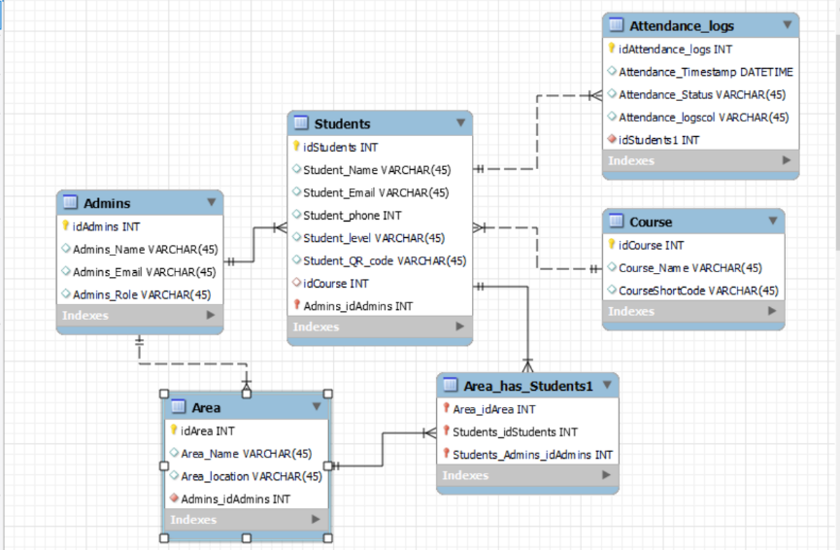

Figure 3.1: Entity Relationship Diagram

## **3.3.2 USE CASE DIAGRAM**

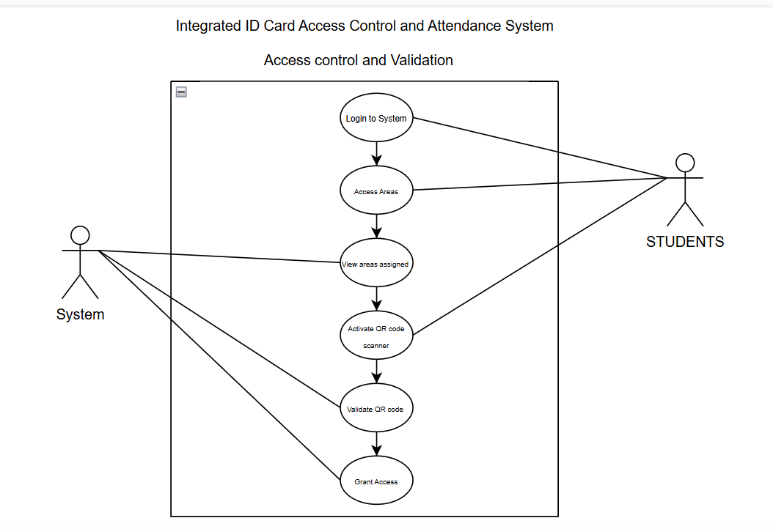

Figure 3.2: Use Case Diagram 1

Use Case: Access control and Validation

*Table 3.3 Access control and Validation use case*

|  |  |
| --- | --- |
| **ATTRIBUTE** | **DESCRIPTION** |
| **Use case Name** | Access control and Validation |
| **Description** | This use case describes how the system controls and Validates students’ access to restricted areas. |
| **Actors** | -System: Reads and Validates QR codes to grant access to students.  -Students: Individuals needing access to restricted areas |
| **Preconditions** | 1.The student or user attempting access must already be registered in the system with a valid profile, including a unique ID or QR code.  2.The user must have assigned access permissions for specific areas |
| **Postconditions** | The system must log the access attempt (success or failure) in the database. |
| **Main Flow** | |  | | --- | |  |  |  | | --- | | 1. The student presents a unique code or QR code at the access point. | | 2. For authorized access, the student is granted entry, and attendance is updated if applicable.  3. For unauthorized access, the system sends a notification to the administrator and denies entry. | |
| **System** | 1. The student presents a unique code or QR code at the access point.  2. The system reads the code and checks its validity in the database.  3. The system validates whether the student has permission to access the specific area.  4. If valid, the system grants access and logs the event.  5. If invalid, the system denies access and sends a notification to the admin. |
| **Exception** | 1. If the system cannot connect to the database, it denies access and prompts an error message.  2. If the QR code or unique code is unreadable, the system prompts the student to try again.  3. If an unauthorized access attempt is detected, the system sends an alert to the admin. |
| **Alternative**  **Flow** | 1. If the student forgets their unique code, they can request admin assistance to retrieve or reset it. |

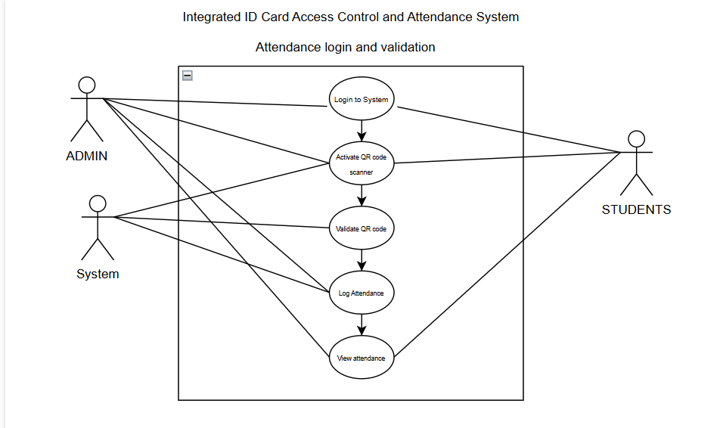

Figure 3.3: Use Case Diagram 2

Use Case: Attendance Login and Validation

*Table 3.4 Attendance Login and Validation use case*

|  |  |
| --- | --- |
| **ATTRIBUTE** | **DESCRIPTION** |
| **Use case Name** | Attendance Login and Validation |
| **Description** | This use case describes the interaction between the system, admin and students when validating and storing students’ attendance. |
| **Actors** | -System: Reads and validates QR codes or unique codes and stores attendance records in the database.  -Students: Individuals logging their attendance using a unique code or QR code.  -Admin: Monitors attendance records, resolves issues, and generates attendance reports. |
| **Preconditions** | 1. The student must have a valid profile in the system with a registered unique ID or QR code.  2. The system must have an active connection to the database to validate and store attendance records. |
| **Postconditions** | 1. Attendance is successfully logged in the database for the specific student, date, and time.  2. Admins can view or generate attendance reports based on the recorded data. |
| **Main Flow** | 1. The student presents a QR code or enters a unique code at the attendance point.  2. The system reads the code and validates it against the database.  3. If valid, the system records the attendance with the student ID, timestamp, and session details.  4. The system provides real-time feedback to the student (e.g., "Attendance Logged Successfully").  5. The admin can access the attendance records for monitoring or reporting purposes. |
| **Exception** | If the QR code or unique code is invalid, the system denies the attempt and notifies the student. |
| **Alternative**  **Flow** | |  | | --- | |  |  |  |  | | --- | --- | | 1. If the QR code scanner fails, the student manually enters their unique code. | | |  |  |  | | --- | | 2. If the student forgets their code, they request admin assistance to retrieve it. |   3. Admin can manually log attendance for students if the system encounters technical issues. |

## **3.3.3 ACTIVITY DIAGRAM**

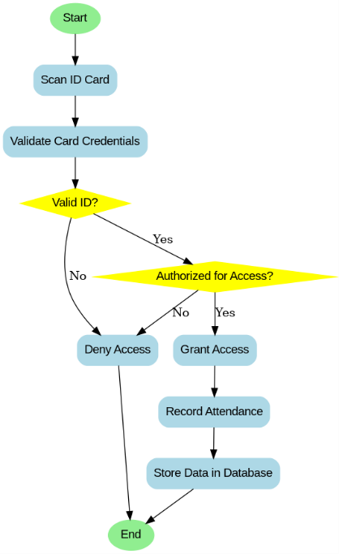

Figure 3.4: Activity Diagram

## **3.3.3 DATA FLOW DIAGRAM**

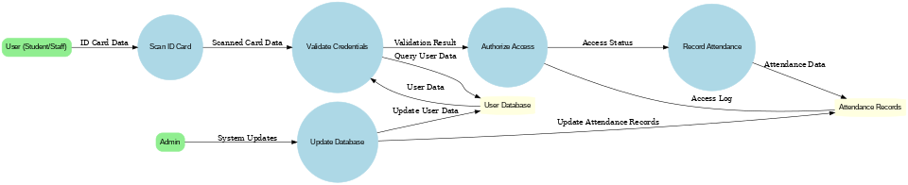

Figure 3.5 Data Flow Diagram

# **CHAPTER FOUR**

# **SYSTEM IMPLEMENTATION**

## **4.1 INTRODUCTION**

This chapter focuses on the Implementation and testing phase of the system, to ensure that the system meets its functional and non-functional requirements. It details on the key features, tools and languages used. Additionally, it includes an explanation on how the system works, guiding users (students and administrators) on how to effectively use the system.

## **4.2 TOOLS AND LANGUAGES USED**

## **4.2.1 Visual Studio code (VS code)**

VS Code is a lightweight yet powerful source code editor developed by Microsoft. It supports a wide range of programming languages and offers features such as syntax highlighting, intelligent code completion, debugging, and version control integration. It is used to write, debug, and manage Python, Django, HTML, and other project-related code. Its extensions for Python and Django streamline the development workflow.

## **4.2.2 Python**

Python is a versatile and high-level programming language known for its readability and ease of use. It is widely used for web development, data analysis, scripting, and automation. Python serves as the backend programming language for the project. Specifically, handling authentication by validating user credentials and managing secure access to the system and Backend Logic by Running the server-side logic for the attendance tracking and access control features.

## **4.2.3 Django**

Django is a high-level Python web framework that enables the rapid development of secure and scalable web applications. It follows the Model-View-Template (MVT) architecture, which simplifies backend development and integration with databases. It is being used in the project to Store and modify information about users, courses, and restricted areas in the database. It provides an interface for administrators to manage users, attendance, and other system data and Serves as the core for building your application’s backend, including database operations and routing requests.

## **4.2.4 Mailtrap.io**

Mailtrap.io is an email testing tool designed for developers. It provides a secure environment to test and debug email functionality without sending actual emails to real users. In this project it is being used to notify administrators when an unauthorized access attempt is detected and to ensure that email notifications are correctly formatted and functioning before deployment.

## **4.3 USER INTERFACE**

## **4.3.1 STUDENT USER INTERFACE**

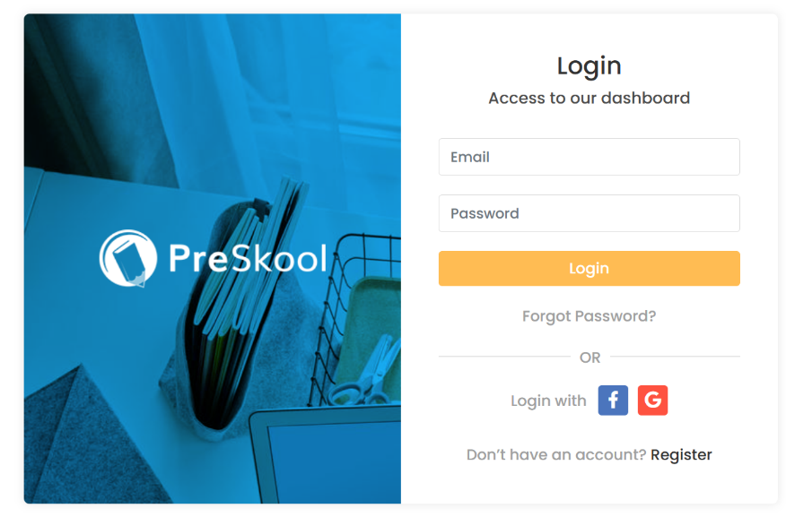

Figure 4.1 Student login page

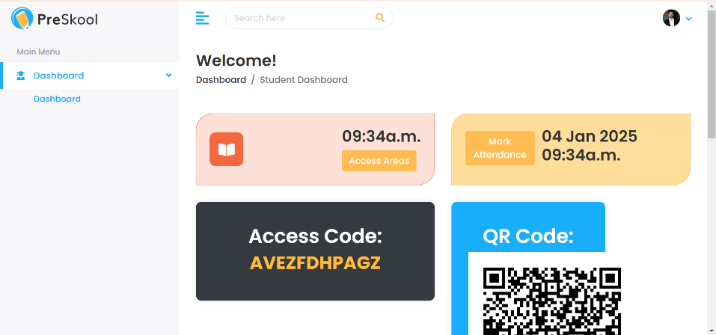

Figure 4.2 Student Dashboard

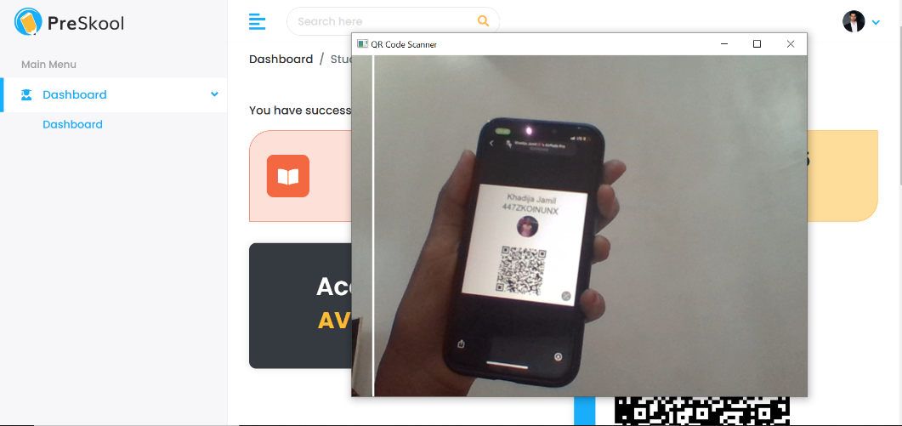

Figure 4.3 Attendance QR code Scanner

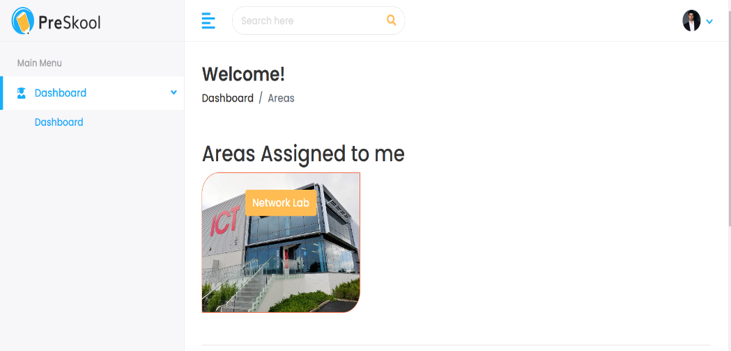

Figure 4.4 Access Areas

## **4.3.2 ADMIN USER INTERFACE**

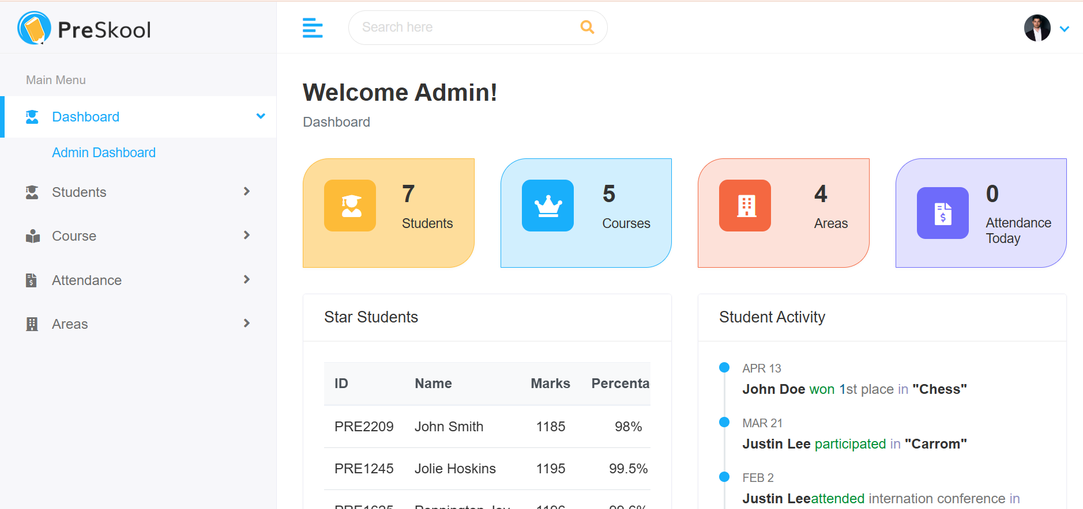

Figure 4.5 Admin Dashboard

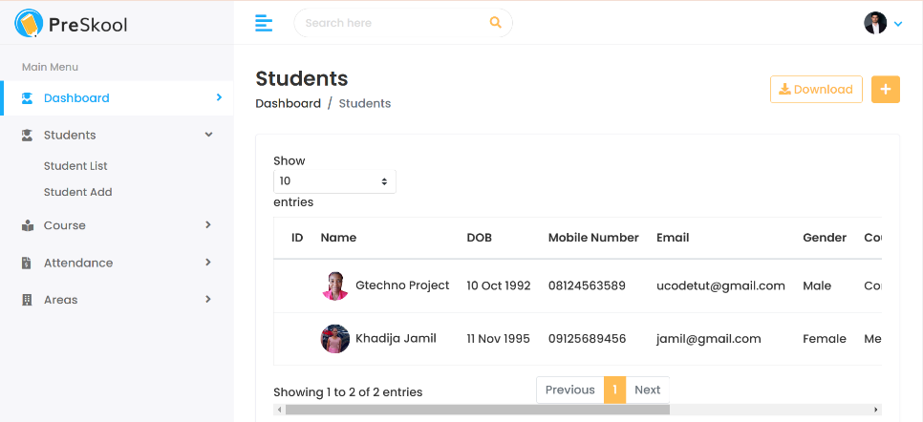

Figure 4.6 Student list

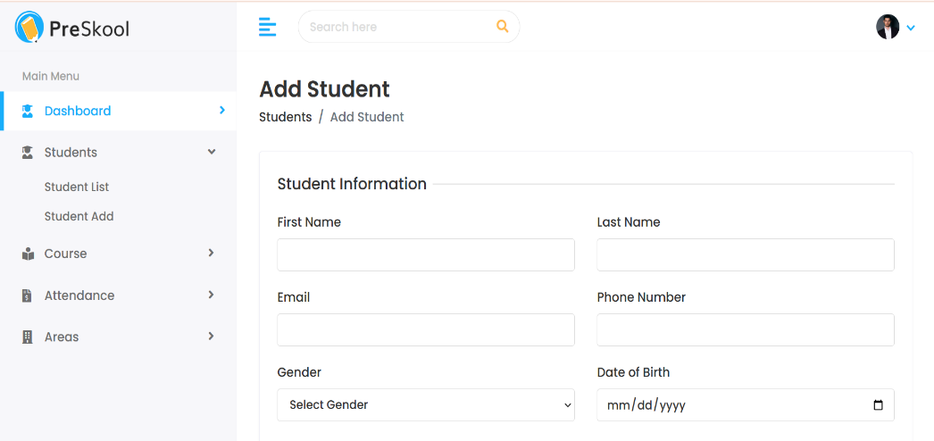

Figure 4.7 Add student 1

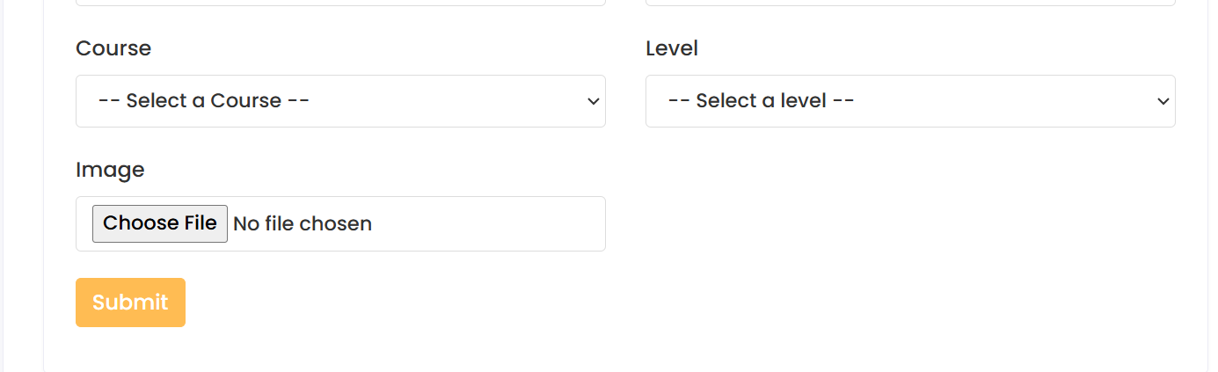

Figure 4.8 Add student 2

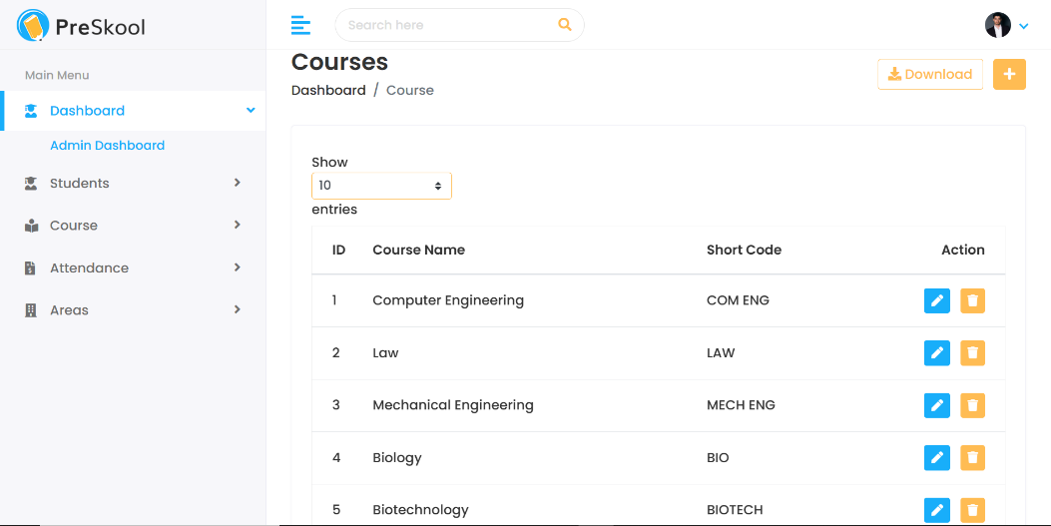

Figure 4.9 Course List

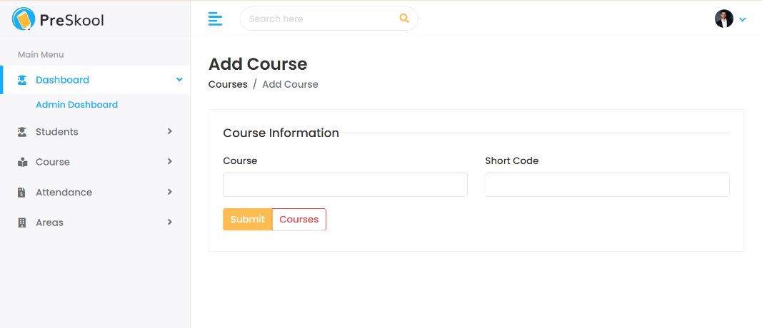

Figure 4.10 Add Course

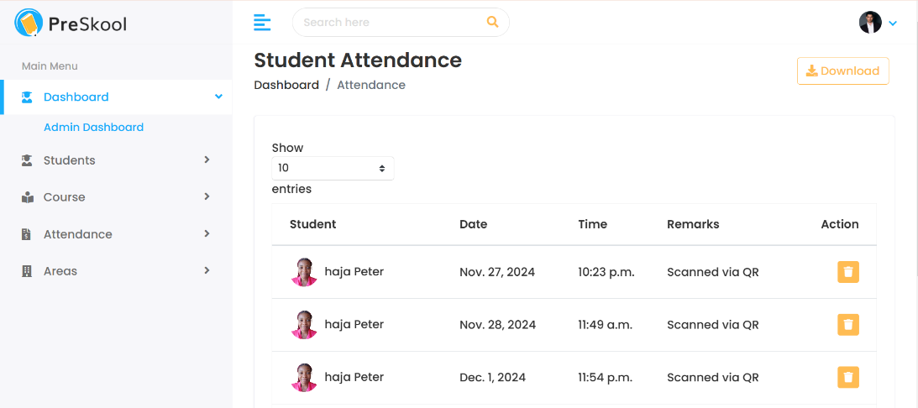

Figure 4.11 Attendance List

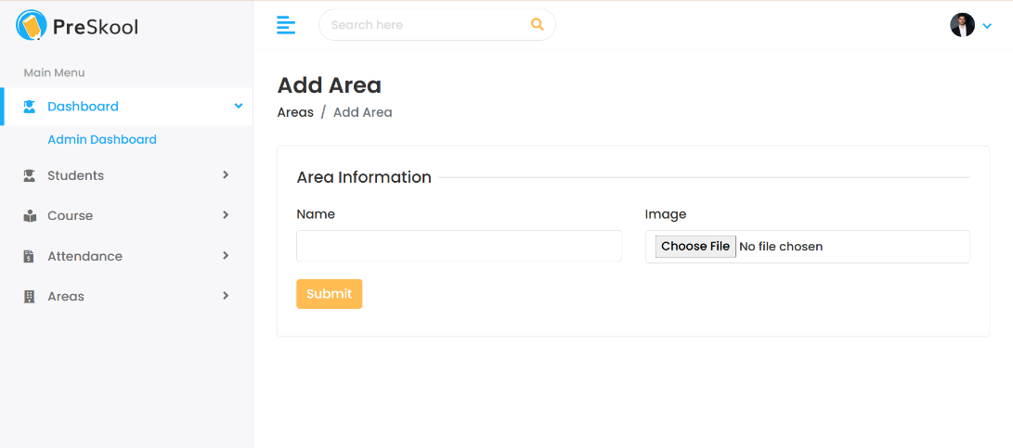

Figure 4.12 Add Area

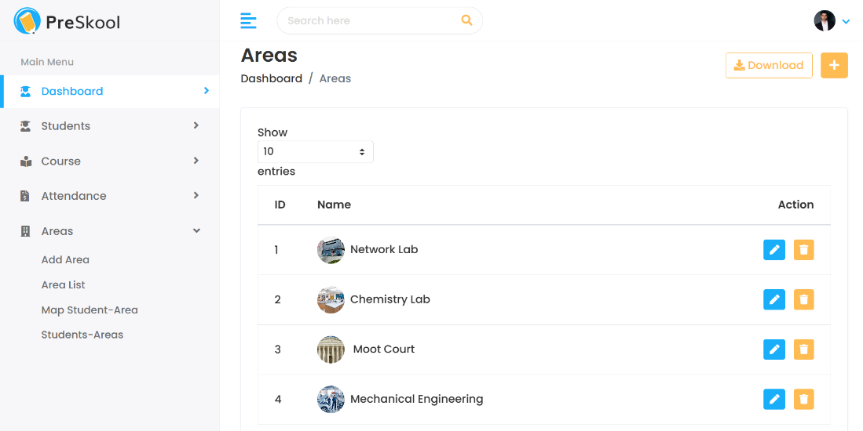

Figure 4.13 Area List

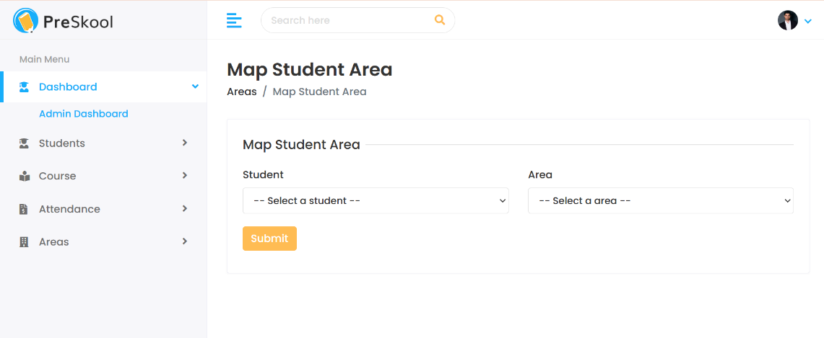

Figure 4.14 Map Student Area

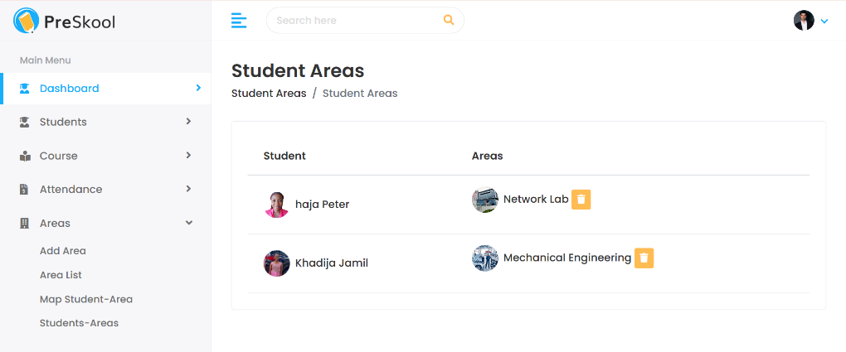

Figure 4.15 Student Areas

## **4.3.3 DATA BASE IMPLEMENTATION**

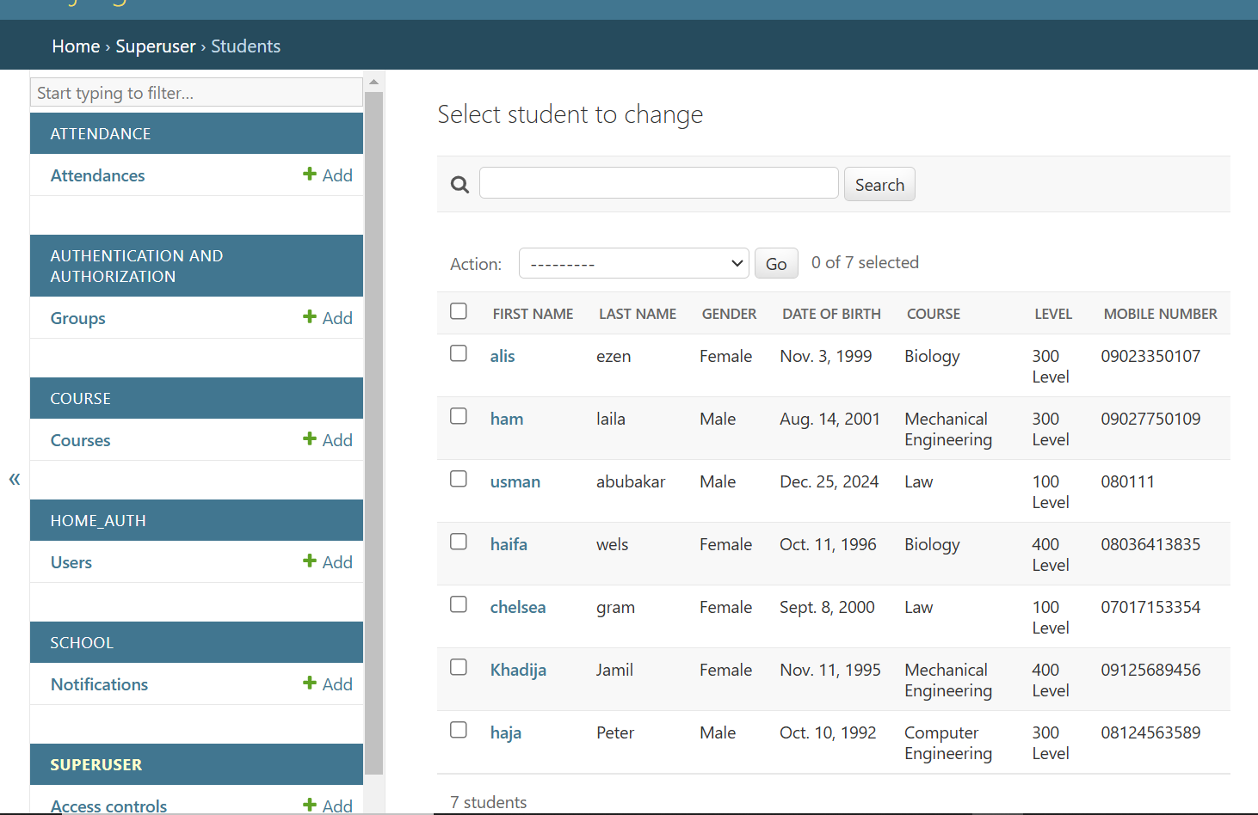

Figure 4.16 Student List

## **4.4 SYSTEM TESTING**

To ensure that the **Integrated ID Card Access Control and Attendance System** met its functional and non-functional requirements, a comprehensive testing process was undertaken. The system underwent multiple phases, including unit testing, integration testing, and system testing, to validate its accuracy, reliability, and usability. Unit testing focused on verifying individual components, such as the authentication module, QR code scanning, attendance logging, and admin management functionalities, ensuring that each module performed as intended. Integration testing evaluated the interactions between the frontend, backend, and database, confirming that data flowed seamlessly between modules. Key areas tested included database integration for storing attendance logs, frontend-backend communication, and the notification system for unauthorized access alerts. Finally, system testing assessed the overall performance, usability, and reliability of the system under real-world conditions, testing scenarios like student login and attendance logging, access control validation, and admin operations. Issues identified during these phases, such as database inconsistencies and notification delays, were promptly resolved, resulting in a stable and efficient system.

*Table 4.1 Summary of functionality test*

|  |  |  |  |  |  |
| --- | --- | --- | --- | --- | --- |
| **Test Objective** | **Test Steps** | | **Expected Results** | **Actual Result** | **Pass/Fail** |
| Student Login | | 1. Access login page | Login page is displayed | Login page is displayed | Pass |
| 2. Enter valid credentials | User is authenticated and redirected | User is authenticated and redirected | Pass |
| 3. Enter invalid credentials | Error message is displayed | Error message is displayed | Pass |
| Attendance Logging | | 1. Access attendance logging section | Attendance input field is displayed | Attendance input field is displayed | Pass |
| 2. Input unique code | |  | | --- | |  |  |  | | --- | | Attendance is successfully logged | | Attendance is successfully logged | Pass |
| |  | | --- | |  |  |  | | --- | | 3. Scan QR code | | Attendance is successfully logged | Attendance is successfully logged | pass |
| Access Control | | 1. Request access to an assigned area | Access is granted | Access is granted | pass |
| |  | | --- | | 2. Request access to an unassigned area |  |  | | --- | |  | | Access is denied and logged | Access is denied and logged | pass |
| |  | | --- | | 3. Unauthorized access attempt | | Admin is notified | Admin is notified | Pass |
| Admin Dashboard | | 1. View system statistics | Dashboard displays key statistics | Dashboard displays key statistics | pass |
| 2. Add new student | Student record is added to the database | Student record is added to the database | pass |
| |  | | --- | |  |  |  | | --- | | 3. Update access permissions for a student | | Permissions are updated successfully | Permissions are updated successfully | Pass |
| 4. Generate attendance report | Report is generated successfully | Report is generated successfully | pass |
| Notifications | | |  | | --- | |  |  |  | | --- | | 1. Trigger unauthorized access attempt | | Notification is sent to the admin | Notification is sent to the admin | pass |
| 2. Email delivery failure scenario | Retry mechanism is triggered | Retry mechanism is triggered |

*Table 4.2 Summary of Non-functionality test*

|  |  |  |  |  |  |
| --- | --- | --- | --- | --- | --- |
| **Test Objective** | **Test Steps** | | **Expected Results** | **Actual Result** | **Pass/Fail** |
| Performance | | 1. Simulate high traffic with multiple users | System handles concurrent users without slowing | System handled concurrent users efficiently | Pass |
| 2. Input multiple attendance records simultaneously | Records are processed without delays | Records were processed in real-time | Pass |
| Scalability | | 1. Add large datasets (students and access areas) | System handles large datasets without crashing | System performed well under high data volume | Pass |
| Security | | 1. Test encrypted storage of sensitive data | Data is securely encrypted in the database | Data was encrypted as expected | pass |
| |  | | --- | | 2. Test secure HTTPS communication |  |  | | --- | |  | | Data transmission is encrypted | HTTPS encryption was functional | pass |
| Usability | | 1. Evaluate student dashboard design | Interface is intuitive and easy to navigate | Interface was found intuitive by test users | pass |
| 2. Evaluate admin dashboard for clarity | Features are clearly labeled and accessible | Admin interface was user-friendly | pass |
| |  | | --- | |  |  |  | | --- | | 3. Provide help tooltips for key features | | Users easily access tooltips for assistance | Tooltips were displayed correctly | Pass |
| Maintainability | | |  | | --- | |  |  |  | | --- | | 1. Apply updates to backend without disruption | | Updates are applied seamlessly | Updates were applied without affecting users | pass |

# **CHAPTER FIVE**

# **DISCUSSION, CONCLUSION AND RECOMMENDATION**

## **5.1 OVERVIEW**

The Integrated ID Card Access Control and Attendance System project aimed to address security and attendance tracking challenges at Baze University. The system was designed to utilize a unique code scanning mechanism for controlling access and logging attendance. By leveraging technologies such as Python, Django, and Ngrok, the project sought to create a secure, efficient, and automated process for ensuring accurate records of attendance while safeguarding university property. This chapter discusses the outcomes of the project, highlights lessons learned, examines the limitations and challenges encountered during implementation, proposes future enhancements, and provides key recommendations.

## **5.2 OBJECTIVE ASSESSMENTS**

The primary objectives of the project were:

1. To develop a system that provides secure access control and accurate attendance logging for students.
2. To ensure data integrity by validating unique student codes and storing attendance records in a backend database.
3. To integrate smart technology for improving efficiency in monitoring and reporting attendance.

The system was successfully implemented, meeting the core objectives. Students could log their attendance and gain access using their unique codes. The backend verified the codes, ensuring security and efficiency in attendance tracking. Moreover, the use of Python and Django enabled the development of a robust and scalable system, while Ngrok provided secure tunneling for testing purposes.

## **5.3 LESSONS LEARNED**

1. Effective Planning: The importance of early-stage planning and research in selecting appropriate technologies. Python and Django, in particular, were effective tools for building the system.
2. Integration Complexity: Integrating the frontend and backend with secure systems can be challenging, requiring precise configurations for smooth interaction between components.
3. User-Friendliness: The need for intuitive interfaces. Though the system was functional, user feedback emphasized the importance of simplicity in the user experience, particularly for students unfamiliar with technology.

## **5.4 LIMITATIONS AND CHALLENGES**

1. Security Concerns: While the system implemented secure code scanning, ensuring that the system was free from vulnerabilities such as code injection or unauthorized access was a significant challenge.
2. Hardware Constraints: Some parts of the system, such as the ID card scanning mechanism, required additional hardware setup that was not fully optimized during development, leading to occasional delays.
3. **Connectivity Issues:** While Ngrok provided an effective way to test the system remotely, network connectivity issues impacted the real-time functionality of the system during testing.

## **5.5 FUTURE ENHANCEMENTS**

1. Biometric Integration: Adding biometric authentication (fingerprint or facial recognition) to complement or replace unique codes for even stronger access control and attendance tracking.
2. Mobile Application: Developing a mobile app to allow students to check their attendance, access campus locations, and receive notifications directly on their smartphones.
3. Offline Functionality: Improving the system’s ability to function offline and sync data once a connection is reestablished, addressing the challenges posed by network dependency.

## **5.6 RECOMMENDATIONS**

1. Scalability Considerations: Future iterations should focus on making the system scalable to accommodate large numbers of students and diverse campus locations.
2. Enhanced Security Features: Stronger encryption methods should be used for storing and transmitting sensitive student data to mitigate any potential security risks.
3. User Training: Offering training sessions for both staff and students on how to effectively use the system would enhance its adoption and success.

## **5.7 SUMMARY**

This chapter discussed the outcomes of the Integrated ID Card Access Control and Attendance System project, which successfully addressed key challenges of security and attendance management at Baze University. The system effectively met its objectives by enabling secure access and accurate attendance tracking. Despite facing challenges such as security concerns, hardware limitations, and connectivity issues, the project provided valuable lessons in system integration and user experience. Future enhancements, including biometric authentication and mobile application development, were recommended to improve the system's scalability, security, and user engagement. The chapter concluded by highlighting the project's success and the potential for its continued evolution.

# **REFRENCES**

Bell, J., & Coates, R. (2019). Smart Card Systems: Balancing Convenience and Security. Journal of Information Security, 15(2), 85-97.

Chaudhary, A., Kumar, V., & Verma, R. (2016). Fingerprint-based Access Control in Large Enterprises: A Case Study. International Journal of Security and Its Applications, 8(3), 45-52.

Das, R., & Paul, S. (2017). Challenges in Biometric Identification: A Survey. Journal of Emerging Technologies in Computing, 6(4), 123-135.

Gavely, J. (2004). Advances in Access Control Systems: From Keys to Biometrics. Security and Management Journal, 12(3), 34-45.

Jain, A. K., Ross, A., & Pankanti, S. (2011). Biometrics: A Tool for Information Security. IEEE Transactions on Information Forensics and Security, 1(2), 125-143.

Jayasuriya, K. (1995). From Mechanical Locks to Electronic Access Control Systems: An Overview. International Journal of Security Studies, 5(1), 34-48.

Johnson, L., & Lee, C. (2019). Cloud-based Solutions for Access Control: A Security and Efficiency Approach. Journal of Computing and Security, 7(3), 34-45.

Kaur, K., & Singh, G. (2013). RFID Technology: Principles, Advantages, Limitations & Its Applications. International Journal of Computer and Electrical Engineering, 5(5), 599-605.

Kim, S., Lee, H., & Park, J. (2014). Fingerprint Recognition for University Access Control System. Journal of Security Engineering, 11(3), 111-119.

Kumar, P., & Srivastava, R. (2021). Integration of Biometric Attendance Systems with ERP for Workforce Management. International Journal of Advanced Computer Science, 13(5), 97-105.

Martínez, D., García, P., & Pérez, M. (2017). Smart Card-based Access Control in Corporate Settings. Security and Communication Networks, 8(3), 55-67.

Patel, S., Gupta, M., & Khan, I. (2019). Data Security in Cloud-based Attendance and Access Control Systems. International Journal of Cloud Computing, 12(1), 112-120.

Prasad, R., Tiwari, P., & Gupta, A. (2018). Integration of Biometric Access Control with Attendance Systems for Workforce Monitoring. International Journal of Applied Engineering Research, 13(10), 7768-7774.

Sharma, R., Thakur, D., & Mishra, K. (2012). Real-time Monitoring with Networked Access Control Systems. Journal of Computer Networks and Communications, 6(2), 121-128.

Smith, T., & Kaye, B. (2020). Challenges in Implementing Modern Access Control Systems: A Practical Approach. International Journal of Information Security, 14(2), 142-153.

Tang, Y., Lee, K., & Wong, R. (2016). Privacy Concerns in Biometric-based Access Control Systems. Journal of Information Security and Privacy, 9(4), 65-72.

Weber, M., & Francis, D. (2017). Security Issues in RFID-based Access Control Systems. International Journal of Secure Computing, 10(1), 23-32.

Wright, J. (2014). The Evolution of Smart Card Technology in Security Systems. Journal of Emerging Technology and Security, 4(3), 77-91.

Yadav, S., Singh, A., & Mehra, P. (2015). Enhancing Security in Corporations with RFID-based Access Control Systems: A Case Study. International Journal of Information Systems, 8(3), 89-98.

Yusuf, M., & Abu-Salem, H. (2020). Cloud-based Access Control Solutions for Multinational Corporations. Journal of Cloud Computing and Security, 11(1), 15-24.